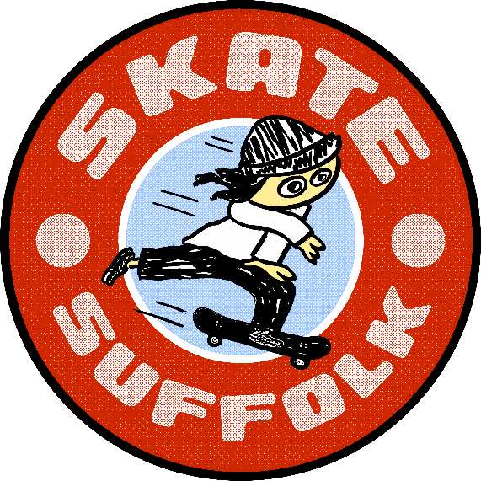
Terms and Conditions

Personal Information
Full Name:

Age:

Ability - Please circle:
First time / Beginner / Confident skateboarder

Emergency contact
Parent or Guardian present for whole session: Yes / No
If no please provide contact details of emergency contact:
Name:
Tel:
Medical information:
Do you have, or have you ever suffered from any medical conditions or injuries that our volunteers should be aware of? E.g. asthma, epilepsy, diabetes, heart problems or allergies - Yes / No
If yes please state:

Have you or any one in your household:
tested positive for COVID-19 in the last 10 days? Yes /No
had any COVID-19 symptoms (see below for details) in the last 10 days? Yes / No
been asked to self-Isolate in the last 10days? Yes / No
- No person is able to participate in the sessions if they have answered to yes to any of the COVID-19 related questions above.
- You declare yourself fit and well to participate in todays session.
- You will listen and follow SkateSuffolk instructions during coaching sessions.
- all under 16s must wear a helmet at all time when participating in a SKate Suffolk event..
- You will keep your helmet on at all times during the coaching session.
- SkateSuffolk do not accept any responsibility for loss, theft or damage to any personal property.
- Should any SkateSuffolk volunteers decide at any time and for any reason that a participant is not behaving in a suitable manner, they may remove the participant from the session immediately.
- Any accident must be reported to a member of SkateSuffolk immediately.
- Whilst we are coaching beginner level course, you acknowledge that the risk of injury from this activity can be significant, and while particular rules, equipment and self-discipline may reduce the risk, the risk of injury does exist. All participants knowingly and freely assume such risks, both known and unknown, and assume full responsibility for their participation and for using appropriate safety equipment.
- For GDPR purposes the details collected on this form will be destroyed within 10 days of the event.

TO BE COMPLETED BY USER IF OVER 16
I acknowledge, appreciate and agree that all sports carried out in the Skatepark can be extremely dangerous and contain a high degree of risk and significant injury. I knowingly and freely accept all such risks and assume full responsibility for my participation. I will comply with the terms of conditions for participation and I agree to follow all instructions given to me by SkateSuffolk staff and volunteers. I hereby give my permission to be photographed or filmed when partaking in SkateSuffolk activities or events and agree that any material obtained can be used for marketing and promotion purposes. In the unlikely event of an accident I hereby release SkateSuffolk and will NOT hold them responsible for any injuries, accidents, loss or damages to person or property. I understand and accept the term and conditions of my participation and agree that I will follow these accordingly. I understand failure to do so could result in my exclusion from activities with SkateSuffolk.
Participant User Name:
Participant User Signature:

Date:
TO BE COMPLETED BY PARENT/GUARDIAN IF UNDER 16 YEARS
I am the parent / guardian of the above and I give my full permission for them to participate in the SkateSuffolk coaching/competition. I understand that they are doing so at their own risk and I also understand the risks involved in these sports. In the unlikely event of an accident I hereby release SkateSuffolk and will NOT hold them responsible for any injuries, accidents, loss or damages to person or property whilst they participate in this activity. I hereby give my permission for my child to be photographed or filmed when partaking in SkateSuffolk activities or events and agree that any material obtained can be used for marketing and promotion purposes. I understand and accept the term and conditions of participation and agree that they will follow these accordingly. I understand failure to do so could result in the exclusion of my child from activities with SkateSuffolk.
Parent / Guardian Name :
Parent / Guardian Signature :

Date:

According to the NHS the main symptoms of coronavirus (COVID-19) are:
- a high temperature – this means you feel hot to touch on your chest or back (you do not need to measure your temperature)
- a new, continuous cough – this means coughing a lot for more than an hour, or 3 or more coughing episodes in 24 hours (if you usually have a cough, it may be worse than usual)
- a loss or change to your sense of smell or taste – this means you've noticed you cannot smell or taste anything, or things smell or taste different to normal.

SkateSuffolk to fill:
Session venue, date and time:
Coach name:

